Token Ring (IEEE 802.5)

Introduction
Token Ring is a LAN protocol developed by IBM and standardized as IEEE 802.5. It uses a ring topology and a token-passing mechanism for medium access. Data travels in one direction around the ring from one device to the next.

Key Features
Feature | Token Ring
Topology | Logical Ring (usually physically a star)
Access Method | Token Passing
Standard | IEEE 802.5
Speed | Typically 4 Mbps or 16 Mbps
Medium | Twisted pair or shielded coaxial cable
Max. Stations | 260 stations (practical limit)

Working Principle
A special frame called a token circulates continuously in the ring. Only the station holding the token is allowed to transmit. After transmission, the station releases the token so other stations can use the network.
- Steps:
- Idle Ring: Token circulates when no station is transmitting.
- Frame Transmission: Station waits for the token, captures it and sends a data frame.
- Frame Circulation: Frame is checked by each station; destination copies and acknowledges it.
- Token Regeneration: The sender removes the frame and releases a new token.

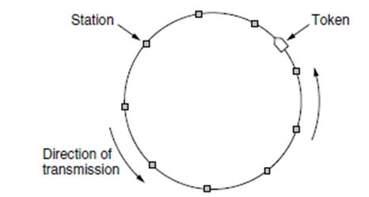

Token Frame Format
Field | Description
Start Delimiter | Marks start of token
Access Control | Priority and reservation bits
Frame Control | Indicates token or data
Destination Address | MAC address of receiver
Source Address | MAC address of sender
Data | Payload
FCS | Frame Check Sequence (error check)
End Delimiter | Marks end of token/data frame

Advantages
- Collision-Free: Only one station transmits at a time.
- Deterministic Access: Guaranteed access without contention.
- Fairness: All stations get equal opportunity.
- High Reliability: Easier to detect and isolate faults.

Disadvantages
- Latency: Wait time for token can increase under load.
- Complex Management: Token maintenance adds overhead.
- Single Point of Failure: Ring break can halt the network (unless using active hubs).

Comparison with Ethernet (CSMA/CD)
Feature | Token Ring | Ethernet (CSMA/CD)
Access Method | Token Passing | Carrier Sense with Collision Detection
Collision | No | Yes
Determinism | Yes | No
Efficiency | Better under high load | Better under low load
Cost | Higher | Lower

Priority System
IEEE 802.5 supports 8 priority levels. Stations can reserve a higher priority for urgent messages. This ensures Quality of Service (QoS) in certain applications.

Physical Implementation
Often implemented using star-wired ring topology. All stations connect to a central hub called MAU (Multistation Access Unit). The MAU maintains the logical ring even if one device fails (bypass feature).

Conclusion
Token Ring provides orderly and fair medium access using a token-passing protocol, suitable for networks requiring predictable performance. However, due to cost and complexity, it has largely been replaced by modern Ethernet technologies.

